VIA University College Denmark
Size of a report:
Can’t be told exactly, however remember quality forth by quantity.
Front page:
From the front page shall appear : Heading of project, own name (full name) name of school and month and year. Make an inviting front page and if a synopsis is selected on the front page this can by asset be framed.
Synopsis:
Summing up from the project and prior conclusions. The synopsis is optionally; however if a synopsis is wanted, it should be short, approx. 10 lines. The synopsis is written to very last, and is recommended placed at the front page.
Preface:
Here are space for personal comments, thanksgiving to persons, institutions or firms, that somehow has assisted. You can also write how literature references, notes etc. are stated.
The preface is nearly always written finally, but must not be a synopsis.
Table of contents:
The table of contents indicating systematically chapter headers, part headers by numbering and page number.
Project description:
Problem analysis:
In the problem analysis you analysis the problem:
- what is the problem?
- is it true that there is a problem? Make documentation by schemes, tables, graphs, literature references etc.
- is the problem consisting / possible rising? (prove)
- what is the reason to the problem?
- what is possible to do / how can you remedy the problem?
Problem statement:
Here the questions are formulated that you try to answer in the project (avoid “yes/no” – questions). If the problem statement is precise it could be contented in one main question – otherwise sub questions are used. Beware to be precise, and do not ask too many questions. In case you during the written phase find out, that you can’t answer on the problem statement you has to rewrite it. A problem statement should always be answered.
Delimitation:
Here you should short and precisely write what do you want to include in the project (that is you describe with words what you have encircled). The delimitation can be stated under consideration to time, missing literature on the province etc.
It could occur that you during the writing process find out, that the problem statement should be delimitated further. Remember it’s better to aim precisely than to shoot with hails.
Time schedule:
It is always a good idea to make an internal time schedule. In that case it is easier to keep self justice. A good time schedule is designed so you clearly can see and estimate planned and used time (see enclosure 1). The time schedule can if necessary be enclosure.
Introduction:
There should be introduced with a briefly introduction to the subject field. It could be of historic or social character.
The proper content of the project (main part):
By this means main sections and/or chapters.
A good chapter mapping out does the report much more clearly. Also remember to supplement the text with pictures/drawings/graphs etc.
Remember to put into perspective. It is important that the reader can see that there is reflection value in the report. Make statements to the topics, and be critical. Keywords: Shine through.
Conclusion:
The conclusion is also a very important element in the report. The conclusion can be seen as an answer to the problem statement and the delimitation.
Personal estimations, for example if the project has been exiting or instructive is not a part of the conclusion, but belong to the evaluation.
Evaluation:
Here you could briefly go through, what went well or bad in the project. After the evaluating it would be naturally to place: date and signature.
Source indication ("list of literature"):
All source indication in the report shall be specified with italic, and there should be used bottom note.
If the source is an illustration, figure, table or similar it should be stated with a bottom note.
The source should be specified precisely and on the same place as used (it is not enough that the source is mentioned in the source indication).
Internet sources are specified with the fully address as shown in the example below:
http://www.dr.dk/arbejdsliv/forside/index.asp
Books are specified with: the name of author, the title of the book, the used pages and year of publication (in the mentioned sequence).
If a book has several authors only the first author is specified.
Articles are specified with: the name of author, the heading of the article, place of publication and date (in the mentioned sequence).
List of literature
The used sources are specified in alphabetic order in relation to the surname of the author. The overall list of literature should give a true picture of the used sources. Only materials actually used in the report must be specified.
Enclosure:
Enclosure should be numbered (chonological), and only enclosure parts referred in the report is included. The first enclosure part is given the number 1, the next number 2 etc. Enclosure is material that do not can or should enter in the main section of the report. The two main reasons to place some materials as enclosure is that the form and extents of the materials make it unpractically to place in the report and that the material is unreadable in direct relation to the text. The enclosure should act as documentation or supplement to the report. Enclosure can be data sheets, legislative texts, summary of conversations etc.
NB! Enclosure materials should not be copied out, but should be pasted in originally to prevent loss of documentation value.

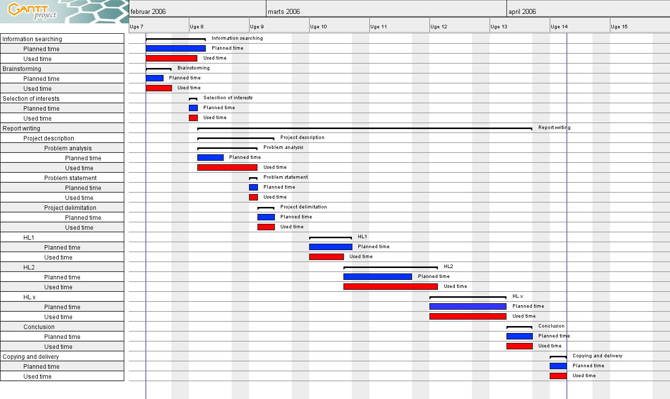
Enclosure 1

