Class Assignment #2 – Structual Design 2. semester

A houseowner want to create a floor construction as seen on picture 1. There are tree longitudinal main beams. One in each facade and one nearby the longitudinal center of the house.

It is your assignment to dimension the longitudinal center beam. The owner would support the beam with 3 point foundations so each of the two span have the same length (named A, B and C).

Picture 1
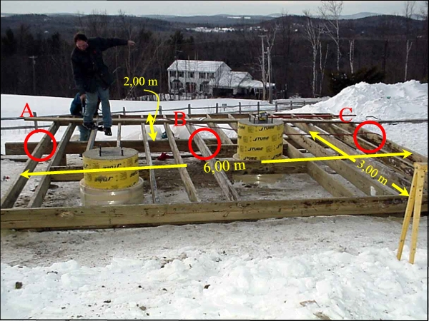

Conditions:
Construction wood class K24.
Load group – L (long term load).
Moisture class 2.
Normal security class.
See also enclosed 1-4.

Dead load:
The floor construction consist of (mentioned from down):
- Secondary spaced boarding – 25x100 mm per 300 mm
- Secondary crossing beams 50x200 mm planks per 600 mm
- 175 mm insulation
- 22 mm wood particle board

Imposed load:
Find the characteristic imposed load q_{k} in DS 410.

Assignments (group work):
- Calculate the characteristic dead load (g_{k}) as a unit load (kN/m²).

- Calculate the load width that act on the longitudinal center beam.

- Calculate the characteristic running meter load (uniform load) on the longitudinal center beam for dead load and imposed load separately.

- Calculate the design value in LAK 1 (DS 409 p. 32) “s_{d} =” - used for deflection.

- Calculate the design value in LAK 2.1 (DS 409 p. 32) “s_{d} =” – used for rupture.

- Calculate the necessary height of the beam. Remember to round up to the nearest buyable profile (aid: assume the width is 75 mm and $W_{y}=\frac{1}{6}⋅b⋅h^{2}$The given formula for W_{y} is only appropriated for massive rectangular cross sections). Assume that the beam are double spanned and the formula for the maximum moment you can find on p. 119 in “Statik” (remember to multiply the founded factor with s_{d} and l²).
- Calculate the maximum deflection. To calculate the maximum deflection you have to imagine that the beam are single spanned - in the real world the deflection would be much smaller because of the continuous structure (aid: $I_{y}=\frac{1}{\text{12}}⋅b⋅h^{3}$The given formula for I_{y} is only appropriated for massive rectangular cross sections).

- If the maximum deflection is larger than the allowed – then recalculate the beam hight.

- If the owner wants to joint the beams as two parts - he has 2 beams each 4,5 m long and the joint is not moment stiff - where would you then recommend him to make the joint? (aid: look at the moment curve for double spanned uniform loaded construction).

- Now we increase the width of the beam to 100 mm. Calculate the same as before, and specify the percentages difference in material use (aid: compare the cross sections).

Best regards
Nicolai Green Hansen

Enclosed 1

The allowable deflection depend on the use of the beam:
Storey partitions: $u_{\text{allowed}}=\frac{1}{\text{450}}\text{ of the span}$
Roof constructions: $u_{\text{allowed}}=\frac{1}{\text{300}}\text{ of the span}$
Beams under a brick wall: $u_{\text{allowed}}=\frac{1}{\text{800}}\text{ of the span}$

Enclosed 2
Enclosed 3

Enclosed 4

